**Enumeration (or enum) in C**

**C enumeration** (**enum**) is an enumerated data type that consists of a group of integral constants. **Enums** are useful when you want to assign user-defined names to integral constants. The **enum** keyword is used to define enums.

## **Defining and Declaring an Enum Type**

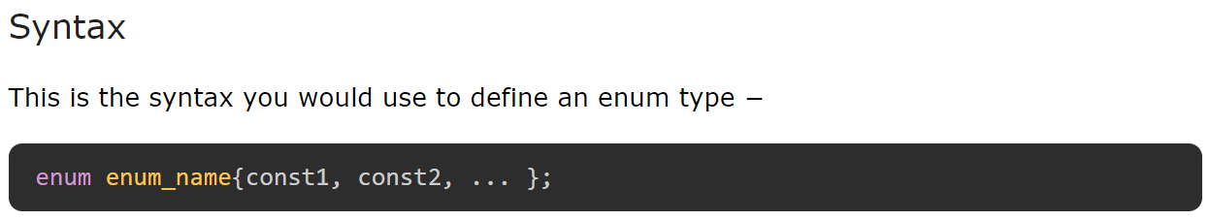

## **Enum Variable Declaration**

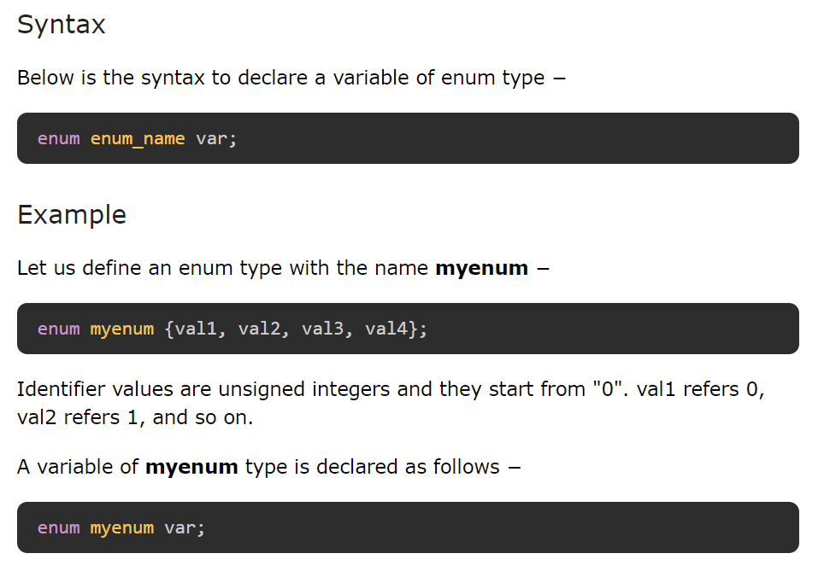

## **Change Enum Constants Values**

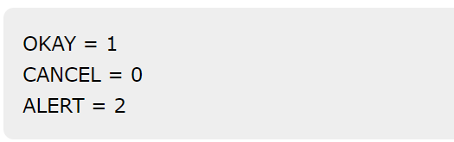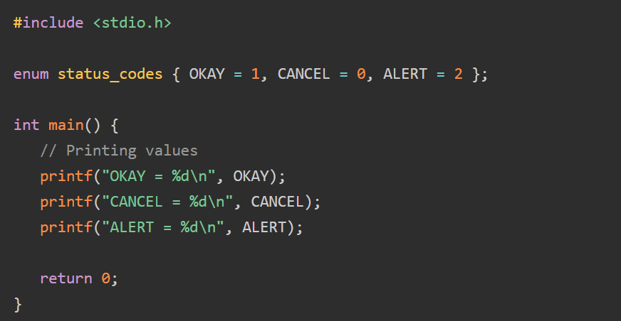

## **Enum in Switch Statements**

C language switch case statement works with integral values. We can use enum type to define constants with (or, without) integral type values to use them in switch case statements.

**#include** <stdio.h>

// Enum declaration

**enum** *colors* { *VIOLET*, *INDIGO*, *BLUE*, *GREEN*, *YELLOW*, *ORANGE*, *RED* };

**int** **main**() {

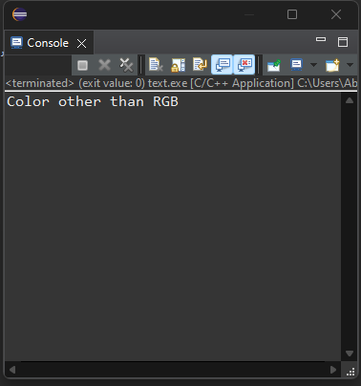 // Enum variable declaration

**enum** *colors* color = *YELLOW*;

// switch statement using enum

**switch** (color) {

**case** *BLUE*:

**printf**("Blue color");

**break**;

**case** *GREEN*:

**printf**("Green color");

**break**;

**case** *RED*:

**printf**("Red color");

**break**;

**default**:

**printf**("Color other than RGB");

}

**return** 0;

}

## **Examples of Enumeration (enum) Type**

### **Example 1: Enum Constants Get Incrementing Integer Values**

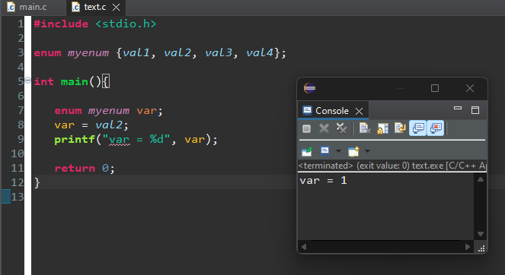

### **Example 2: Enumerating the Weekdays**

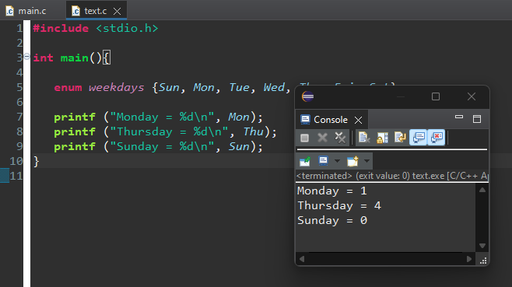

### **Example 3: Declaring a Variable of Enum Type**

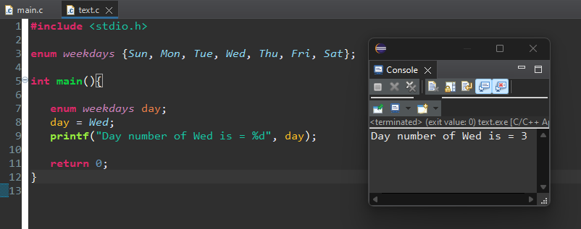

### **Example 4: Enum Values By Default Start from "0"**

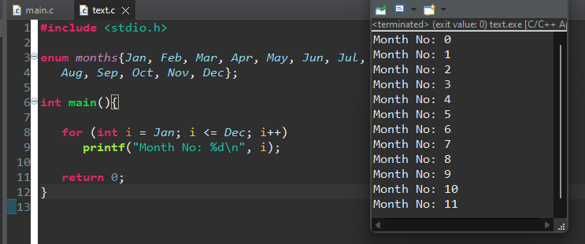

### **Example 5: Starting an Enum from 1**

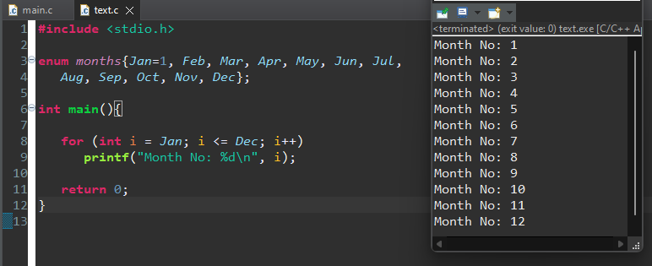

### **Example 6: Enumerating HTTP Status Codes**

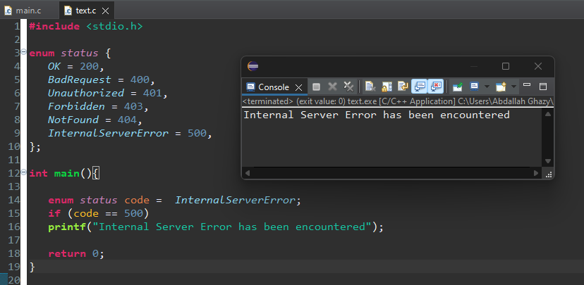

### **Example 7: Assigning a Fixed Number to Enum Constants**

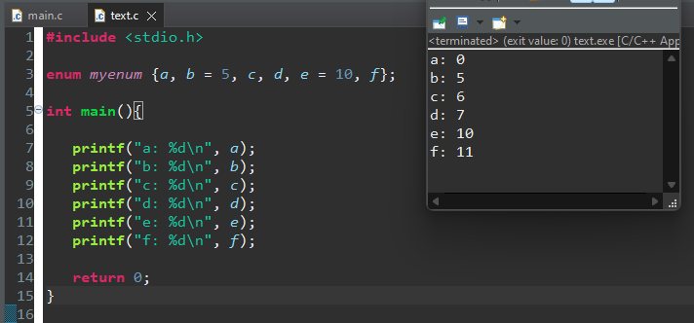

## **Applications of Enums**

* To store constant values, for example, weekdays, months, directions, colors, etc.
* Enums are used for using flags, status codes, etc.
* Enums can be used while using switch-case statements in C.